Feature Branch Workflow

What is Feature Branch Workflow?
# Source: AI Source: Provided by: [Data Path: Persons Table -> ID Column: 1, Name_En Column: Motasem Essam] -> From: [ChatGPT] on [2/15/2026]
Feature Branch Workflow is a version control strategy where each new feature, bug fix, or task is developed in a separate branch instead of directly on the main branch.
The main branch always remains stable and production-ready.
This workflow is widely used in modern Git platforms like GitHub and GitLab.

How It Works
# Source: AI Source: Provided by: [Data Path: Persons Table -> ID Column: 1, Name_En Column: Motasem Essam] -> From: [ChatGPT] on [2/15/2026]
- The main branch stores stable code.
- A developer creates a new branch for a feature:
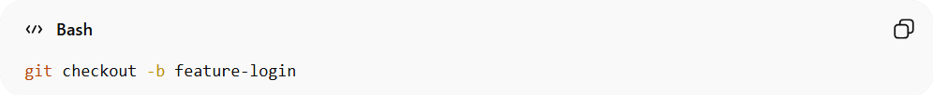
git checkout -b feature-login
- The developer works and commits changes in that branch.
- The branch is pushed to the remote repository:
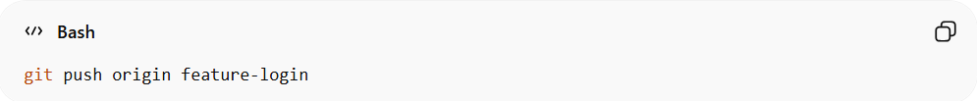
git push origin feature-login
- A Pull Request (PR) or Merge Request (MR) is created.
- Code review and testing are performed.
- After approval, the branch is merged into main.

Conceptual Visualization
# Source: AI Source: Provided by: [Data Path: Persons Table -> ID Column: 1, Name_En Column: Motasem Essam] -> From: [ChatGPT] on [2/15/2026]
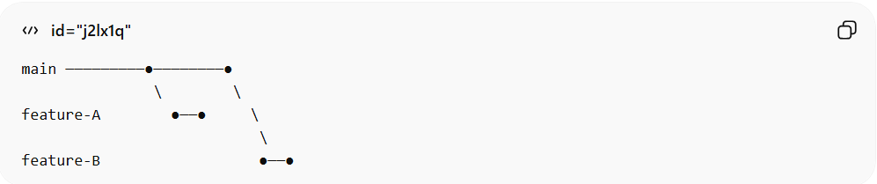
main ─────────●────────●
\ \
feature-A ●──● \
\
feature-B ●──●
Each feature has its own isolated development line before merging.

When It Is Used
# Source: AI Source: Provided by: [Data Path: Persons Table -> ID Column: 1, Name_En Column: Motasem Essam] -> From: [ChatGPT] on [2/15/2026]
- Medium to large teams
- Projects requiring code review
- Applications with CI/CD pipelines
- Production environments needing stability

Advantages
# Source: AI Source: Provided by: [Data Path: Persons Table -> ID Column: 1, Name_En Column: Motasem Essam] -> From: [ChatGPT] on [2/15/2026]
- Keeps main stable
- Isolates unfinished work
- Supports code review process
- Works well with CI/CD
- Scales efficiently for teams

Disadvantages
# Source: AI Source: Provided by: [Data Path: Persons Table -> ID Column: 1, Name_En Column: Motasem Essam] -> From: [ChatGPT] on [2/15/2026]
- Requires branch management
- Possible merge conflicts
- Needs team discipline
- Slightly more complex than centralized workflow

Key Idea (Exam Summary)
# Source: AI Source: Provided by: [Data Path: Persons Table -> ID Column: 1, Name_En Column: Motasem Essam] -> From: [ChatGPT] on [2/15/2026]
Feature Branch Workflow = One branch per feature → Review → Merge → Stable main branch
It is a structured and scalable workflow widely used in modern Version Control Systems.

